
2025 – 2026
Spring 1: January 2026
Reception

Happy New Year!
We’re so excited to begin a brand-new term filled with curiosity, creativity, and plenty of opportunities to grow. This spring, the children will be exploring new learning adventures, building on their independence, and enjoying the changing season as we move towards lighter days.

Attendance and Punctuality
Children should be ready to start school at 8:55am – class teachers are on the playgrounds from 8:50am so that they can meet the children and be ready in the classrooms for 8:55am.
Children are marked as late if they arrive between 9am and 9:15am. Children arriving after 9:15am receive a ‘late after registers have closed’ mark which is classed as an unauthorised absence.

If your child is going to be absent from school for any reason, please contact us to let us know why.

When attendance drops below 90% it is classed as persistent absence.

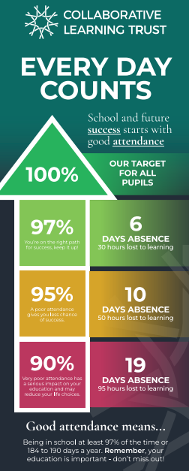
School Uniform
- Lemon yellow polo shirt
- Jade green jumper or cardigan (with or without the school logo)
- Grey trousers, skirt, shorts or pinafore
- Black shoes or trainers
- Yellow summer dress

PE Kit
- White t shirt
- Black or navy leggings, shorts, jogging bottoms (no branded logos)
- Trainers
- Black or navy hoody for outdoor PE (school jumper to be worn during the day)

Dates for Your Diary
January
Monday 5th – school closed for Training Day
Tuesday 6th – school opens
Wednesday 21st @9am – Come and See: Maths for Reception and Key Stage 1
Tuesday 27th @9am – Come and See: Maths for Key Stage 2
Wednesday 28th @9am – Year 4 Amber Class Worship

February
Wednesday 28th @9am – Year 3 Sapphire Class Worship
Monday 9th – Children’s Mental Health Week
Tuesday 10th – Safer Internet Day
Wednesday 11th – Coffee Morning for parents/carers with Ms Crisp
Friday 13th – school closes for half term
Monday 23rd – school opens

How you can help at home with phonics:
- Enjoy short, positive reading moments together to help build confidence.
- Practise the week’s phonics sounds in a fun, relaxed way.
- Play simple sound games like “I spy something beginning with…”
- Help your child blend words by saying each sound slowly (c-a-t).
- Spot letters and words in everyday places such as signs, labels, and packaging.
- Share lots of stories to build vocabulary and a love of reading.
- Praise effort and ‘having a go’ rather than focusing on getting it right.
- Keep phonics fun and pressure-free so your child enjoys learning.
.

Curriculum Information

Phonics-
ai ee igh oa oo oo ar or ur ow oi ear air er
• words with double letters
• longer words
Tricky words: was you they my by all
are sure pure

Maths-
Subitise within 5 focusing on die patterns
Match numerals to
quantities within 5
Counting – focus on ordinality and the ‘staircase’

RE: Which places are special and why?

PSHE: Being my best
PE: Dance
English: Drawing Club
One Snowy Night
Three Little Pigs
Owl Babies
Goldilocks and the three bears

How you can help at home with maths:
- Make maths part of everyday life: Count steps, apples, toys, or anything you come across during the day.
- Use real objects to explore numbers: Buttons, pasta, blocks, or coins are perfect for sorting, counting, and comparing.
- Talk about shapes and patterns: Spot circles, squares, stripes, and repeating patterns around the home or outdoors.
- Build early measuring skills: Compare which cup is fuller, which teddy is heavier, or who has the longest scarf.
- Play simple number games: Board games, dice games, and matching cards help build number sense in a fun way.
- Use mathematical language: Words like more, fewer, bigger, smaller, next to, and in front of help children understand concepts.

Let your light shine before others that they may see your good deeds and glorify your Father in heaven, Matthew 5:16
Aspiration – Courage – Kindness – Forgiveness – Respect - Community

